BEST TO DEFINE FUNCTIONS IN PROTOTYPE

* Single instance of each function when the object is instantiated
* Unlike in constructors, every time there is a new instantiation, a new instance of that function is created

RECOMMENDED METHOD FOR PROTOTYPAL INHERITANCE

* Object.create
  + <https://developer.mozilla.org/en-US/docs/Web/JavaScript/Reference/Global_Objects/Object/create>

Syntax:

Object.create(proto)

Object.create(proto, propertiesObject)

* This is primarily used for prototypes inheriting functions from other prototypes

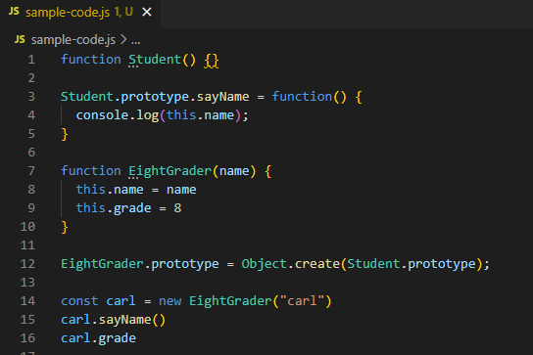

Warning! This doesn’t work:



* This is not inheritance, this is just assignment! You cannot add distinct properties for EightGrader if you used this

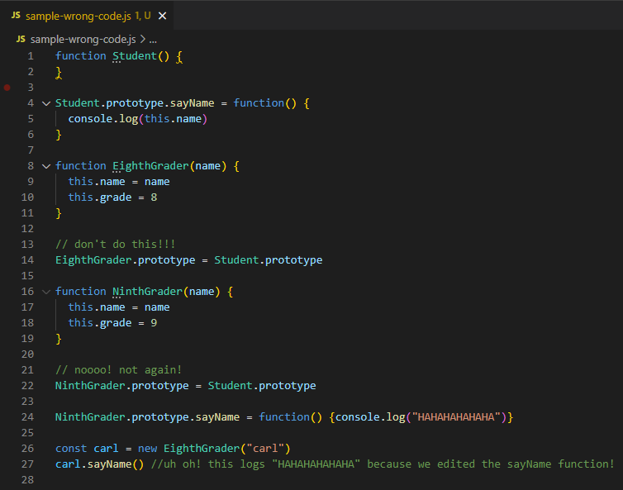

* Changing one property even if it is just a child prototype, will change every property of that name including its siblings